**DAILY ONLINE ACTIVITIES SUMMARY**

|  |  |  |  |  |  |  |  |
| --- | --- | --- | --- | --- | --- | --- | --- |
| **Date:** | **21-06-2020** | | | | **Name:** | **B.A.SOHANKUMAR** | |
| **Sem & Sec** | **4TH SEM A** | | | | **USN:** | **4AL18CS013** | |
| **Online Test Summary** | | | | | | | |
| **Subject** | | **----** | | | | | |
| **Max. Marks** | | **----** | | **Score** | | **----** | |
| **Certification Course Summary** | | | | | | | |
| **Course** | **CLOUD COMPUTING WITH AWS** | | | | | | |
| **Certificate Provider** | | | **GLA** | **Duration** | | | **12 HOURS** |
| **Coding Challenges** | | | | | | | |
| **Problem Statement: Write a C program to rotate a matrix by 90degree in clockwise or anticlockwise direction.** | | | | | | | |
| **Status:EXECUTED** | | | | | | | |
| **Uploaded the report in Github** | | | | **YES** | | | |
| **If yes Repository name** | | | | **LOCKDOWN CODING** | | | |
| **Uploaded the report in slack** | | | | **YES** | | | |

CERTIFICATION COURSE DETAILS;

Course:CLOUD COMPUTING WITH AWS

Today I have opted this new course and this course has a video content of 12 hours.Completed modules today are Module 1 - Core Building Blocks, Abstraction, AWS Console,Module 2 - Compute - Elastic Compute Cloud or EC2,Module 2a - AWS EC2 Step 3 - Advance Features Part I,Module 2b - AWS EC2 Step 3 - Advance Features Part II,Module 3 - How to SSH in to an EC2 Instance,SSH Options for Windows Users,Module 4 - Load Balancing, Fault Tolerance & CloudWatch,Load Balancer (Additional Information),Module 5 - Windows EC2 Instance, Instance Pricing,Module 6 - Identity & Access Management.

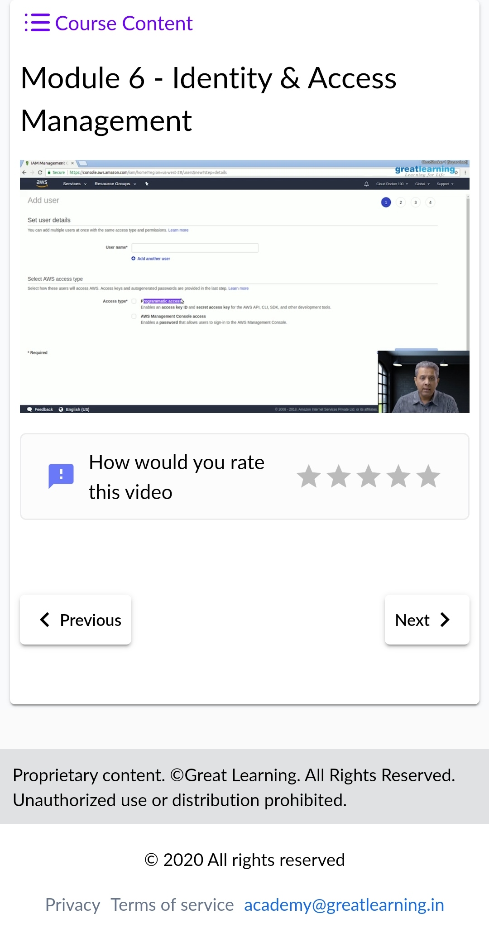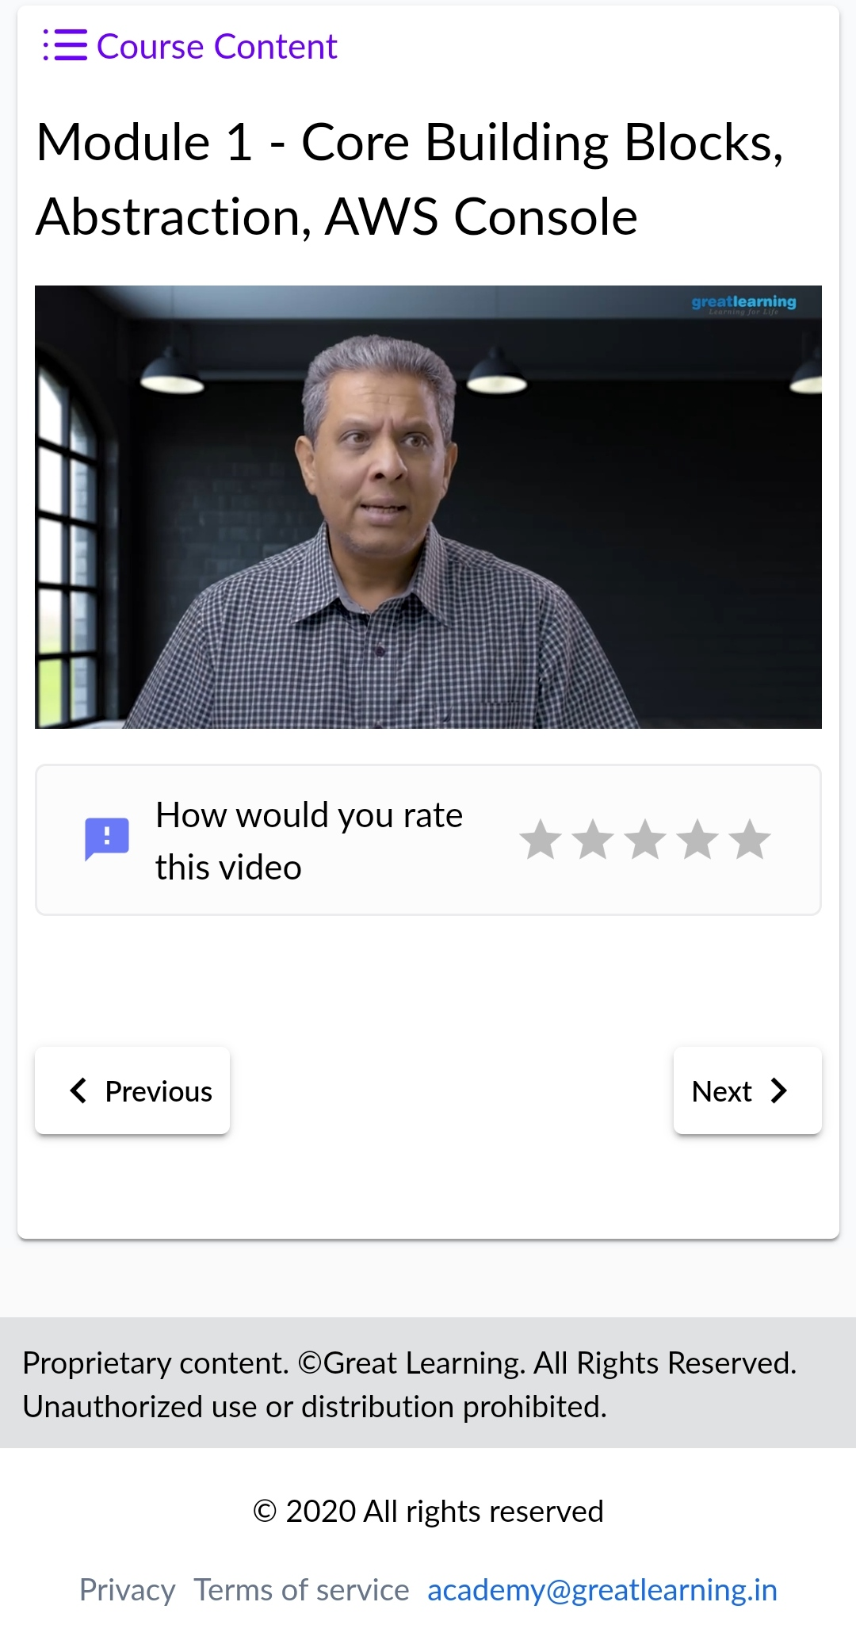

CODING CHALLENGES DETAILS:

1.Write a C Program to rotate a Matrix by 90 Degree in Clockwise or Anticlockwise Direction. Implement (Both the rotations in single program using switch case statement).

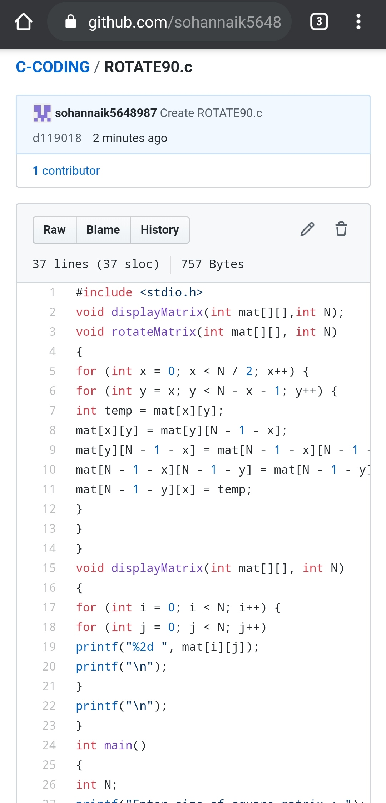

REPOSITORY LINK:https://github.com/sohannaik5648987/C-CODING